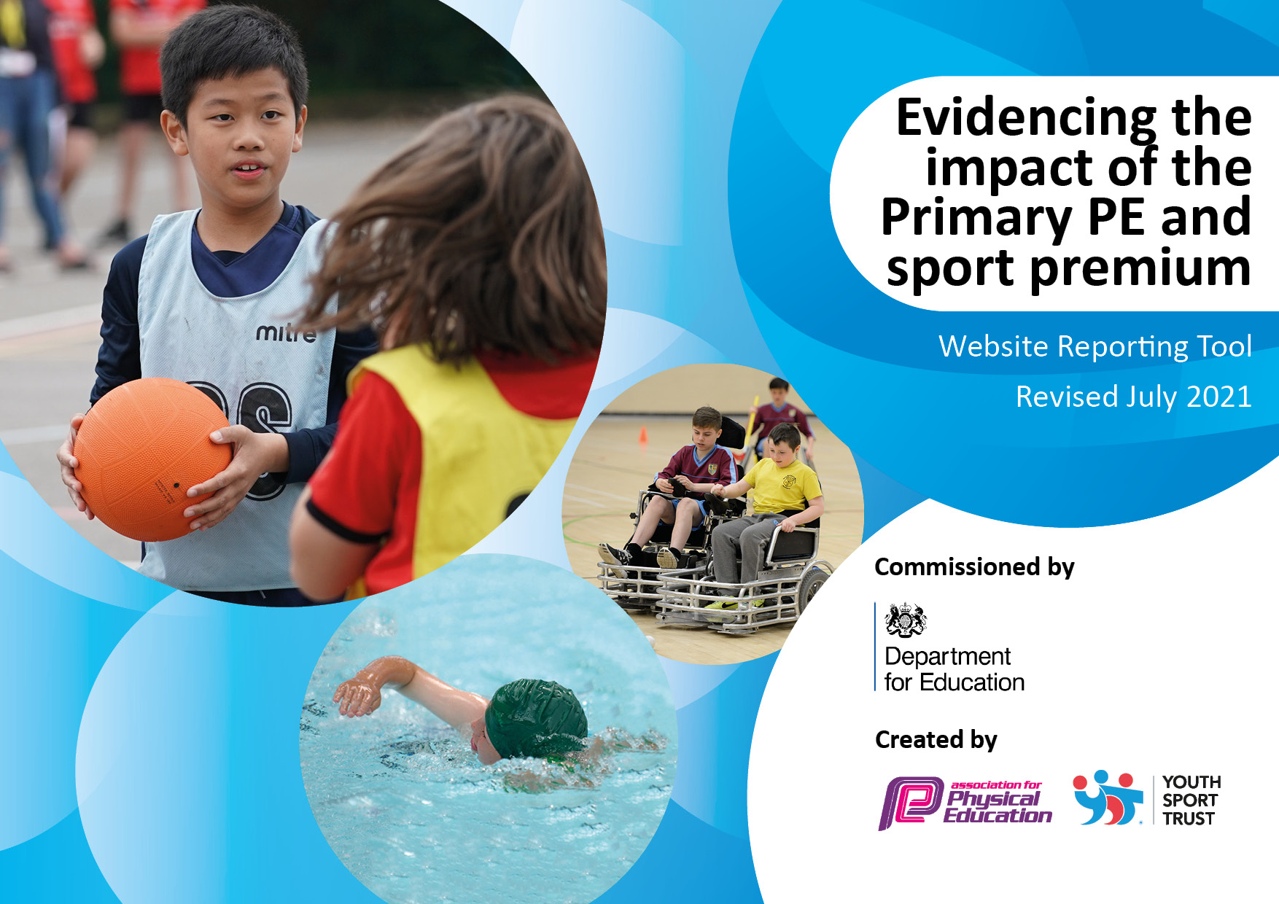
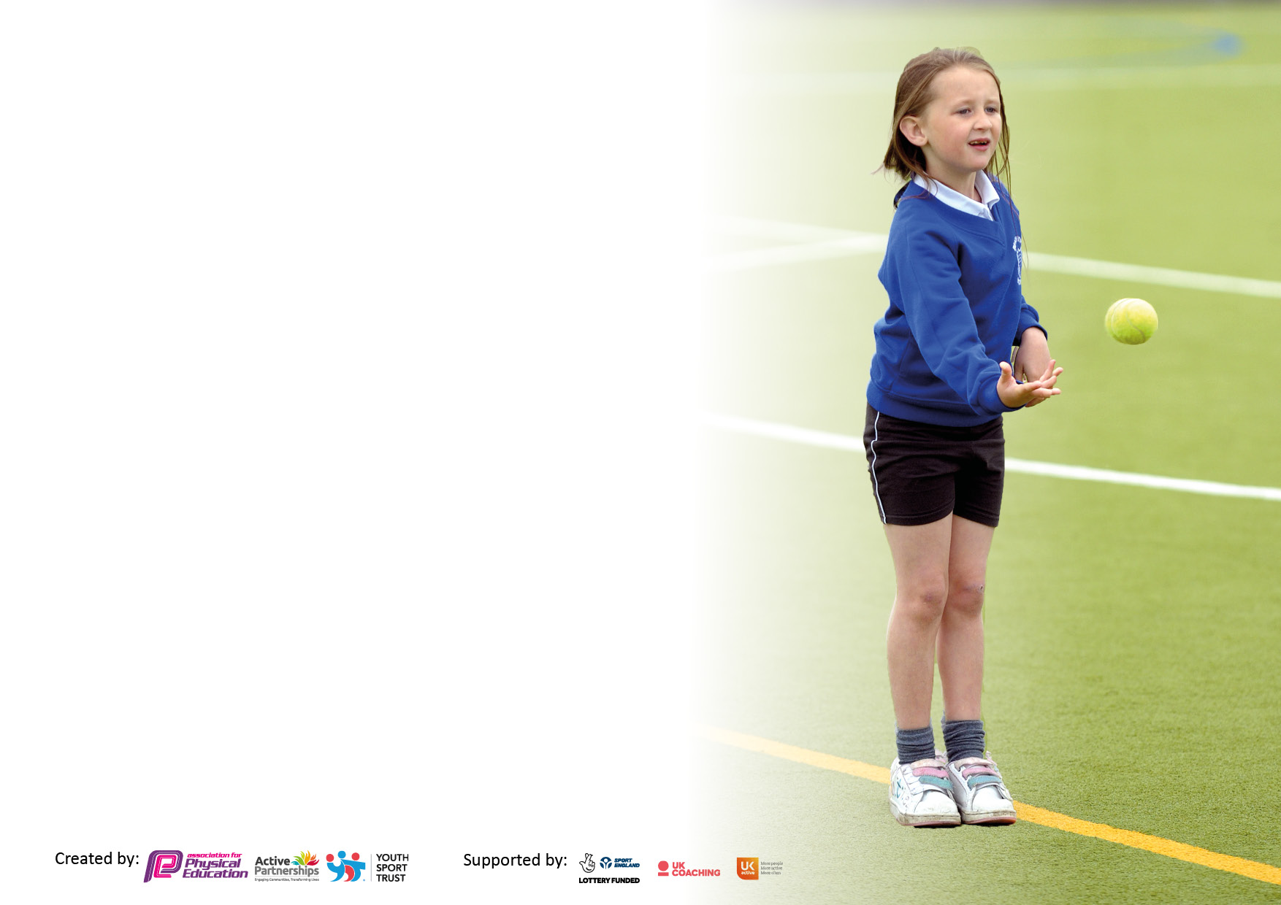

It is important that your grant is used effectively and based on school need. The Education Inspection Framework makes clear there will be a focus on ‘whether leaders and those responsible for governors all understand their respective roles and perform these in a way that enhances the effectiveness of the school’.

Under the Quality of Education Ofsted inspectors consider:
Intent - Curriculum design, coverage and appropriateness
Implementation - Curriculum delivery, Teaching (pedagogy) and Assessment
Impact - Attainment and progress

To assist schools with common transferable language this template has been developed to utilise the same three headings which should make your plans easily transferable between working documents.

Schools must use the funding to make additional and sustainable improvements to the quality of Physical Education, School Sport and Physical Activity (PESSPA) they offer. This means that you should use the Primary PE and sport premium to:

- Develop or add to the PESSPA activities that your school already offer
- Build capacity and capability within the school to ensure that improvements made now will benefit pupils joining the school in future years
- The Primary PE and sport premium should not be used to fund capital spend projects; the school’s budget should fund these.

Pleasevisitgov.ukfortherevisedDfEguidanceincludingthe5keyindicatorsacrosswhichschoolsshoulddemonstrate animprovement.Thisdocumentwillhelpyoutoreviewyourprovisionandtoreportyourspend.DfEencouragesschools to use this template as an effective way of meeting the reporting requirements of the Primary PE and sport premium.

We recommend you start by reflecting on the impact of current provision and reviewing the previous spend.

Schools are required to publish details of how they spend this funding, including any under-spend from 2019/2020, as well as on the impact it has on pupils’ PE and sport participation and attainment. All funding must be spent by 31st July 2022.

We recommend regularly updating the table and publishing it on your website throughout the year. This evidences your ongoing self-evaluation of how you are using the funding to secure maximum, sustainable impact. Final copy must be posted on your website by the end of the academic year and no later than the 31st July 2021. To see an example of how to complete the table please click HERE.

Details with regard to funding
Please complete the table below.

Total amount carried over from 2019/20 | £0
Total amount allocated for 2020/21 | £17,360.00
How much (if any) do you intend to carry over from this total fund into 2021/22? | £0
Total amount allocated for 2021/22 | £17,271.60
Total amount of funding for 2021/22. To be spent and reported on by 31st July 2022. | £17,271.60
Swimming Data
Please report on your Swimming Data below.

Meeting national curriculum requirements for swimming and water safety.

N.B. Complete this section to your best ability. For example you might have practised safe self-rescue techniques on dry land which you can then transfer to the pool when school swimming restarts.
Due to exceptional circumstances priority should be given to ensuring that pupils can perform safe self-rescue even if they do not fully meet the first two requirements of the NC programme of study
What percentage of your current Year 6 cohort swim competently, confidently and proficiently over a distance of at least 25 metres?  N.B. Even though your pupils may swim in another year please report on their attainment on leaving primary school at the end of the summer term 2020.  Please see note above | 89.4%
What percentage of your current Year 6 cohort use a range of strokes effectively [for example, front crawl, backstroke and breaststroke]?  Please see note above | 89.4%
What percentage of your current Year 6 cohort perform safe self-rescue in different water-based situations? | 89.4%
Schools can choose to use the Primary PE and sport premium to provide additional provision for swimming but this must be for activity over and above the national curriculum requirements. Have you used it in this way? | Yes

Action Plan and Budget Tracking
Capture your intended annual spend against the 5 key indicators. Clarify the success criteria and evidence of impact that you intend to measure to evaluate for pupils today and for the future.

Academic Year: 2021/22 | Total fund allocated: £17,271.60 | Date Updated: 20.05.2022
Key indicator 1: The engagement of all pupils in regular physical activity – Chief Medical Officers guidelines recommend that primary school pupils undertake at least 30 minutes of physical activity a day in school |  |  |  | Percentage of total allocation:
 |  |  |  | 45.83%
Intent | Implementation |  | Impact
Your school focus should be clear what you want the pupils to know and be able to do and about  what they need to learn and to  consolidate through practice: | Make sure your actions to achieve are linked to your intentions: | Funding allocated: | Evidence of impact: what do pupils now know and what can they now do? What has changed?: | Sustainability and suggested next steps:
- Children to complete the Daily Mile 5 times per week.  - Equipment (e.g., skipping ropes, balls etc.) to be accessible at all playtimes to encourage active play for all.  - After school sports clubs to be offered weekly targeting different key stages and age groups.  - Forest School provision is in place, throughout the year, for children to access outdoor activities.  - To provide opportunities during playtimes and lunchtimes where all children have access to a space that is suitable to engage in physical activity, supported, where necessary, by adults, for children who find it difficult to engage with their peers or who may have physical or cognitive barriers to access this.  - Children in Years 4, 5 and 6 have attended weekly swimming sessions in the Spring term. | - The Daily Mile is timetabled after lunchtime every day for all children in school. Set targets for each class.  - Equipment boxes are colour co-ordinated and accessible during each outdoor play for all children.  - Additional equipment has been purchased during the year, to ensure equipment is replaced when necessary.  - Ensure quality after school sport is being delivered. Promote places in the clubs to target children/age groups.  - To contribute to funding active playtimes with staff who engage, support and encourage pupils to play a variety of games, practise skills and improve their physical and mental health through active play. This has been equitable by ensuring there is heavy support for those children with additional needs, ensuring all children can engage with physical activity. | £7,916.12 | - All children take part in the Daily Mile, 5 times per week.  - Children look after their own playtime equipment and can earn points to add to their class box.  - Children have more active playtimes.  - Teachers, as well as our out of school provider Doncaster Rovers, have provided clubs throughout the year to keep children active.  - Children enjoy forest school and enjoy this outdoor experience.  - Observations throughout the school day show that active PE and playtimes has had a positive impact on children’s physical, mental and social health. | - Midday Supervisors to continue to run, monitor and promote the Daily Mile.  - Identify young play leaders and stay on track with their PE boxes.  - Student council discussions to continue to identify ways to improve PE in school.
Key indicator 2: The profile of PESSPA being raised across the school as a tool for whole school improvement |  |  |  | Percentage of total allocation:
 |  |  |  | %
Intent | Implementation |  | Impact
Your school focus should be clear what you want the pupils to know and be able to do and about  what they need to learn and to  consolidate through practice: | Make sure your actions to achieve are linked to your intentions: | Funding allocated: | Evidence of impact: what do pupils now know and what can they now do? What has changed?: |  | Sustainability and suggested next steps:
- To celebrate children’s participation and achievements during whole school assemblies (e.g., Forest School).  - The use of Twitter and school newsletters have been used to promote and update children’s participation in events.  - To focus on children’s mental wellbeing in addition to their physical health. Additional opportunities for outdoor learning and mindfulness will be incorporated into our curriculum. | - To celebrate the success of teams and/or individuals who have represented our school.  - Updates will be added to our school newsletter and Twitter will be used to promote participation and events. | Allocated above. | - Our outdoor areas have been utilised in different areas of the curriculum. The reflective area has been a useful outdoor space to promote positive thinking and mindfulness.  - Staff have explored outdoor areas and have used these to promote outdoor learning for the children. |  | - This focus is sustainable and will impact for a long length of time.  - Next steps are to continue to utilise outdoor areas to create additional opportunities in the classroom to complete mindfulness activities and brain breaks.

Key indicator 3: Increased confidence, knowledge and skills of all staff in teaching PE and sport |  |  |  | Percentage of total allocation:
 |  |  |  | 30.58%
Intent | Implementation |  | Impact
Your school focus should be clear | Make sure your actions to | Funding | Evidence of impact: what do | Sustainability and suggested
what you want the pupils to know | achieve are linked to your | allocated: | pupils now know and what | next steps:
and be able to do and about | intentions: |  | can they now do? What has
what they need to learn and to |  |  | changed?:
consolidate through practice:
- Doncaster Rovers coaches have worked across Years 2-6.  - For Simon Carson Sports to spend a term with KS2.  - MSA training to support lunchtime staff in delivering a more active playtime. | - Sports coaches to work alongside staff to improve their confidence and competence in PE and keeping children active. | £5,282.50 | - Staff in school are becoming more confident and have more ideas to use across the curriculum. | - To consider a range of coaches to deliver a wider range of activities to inspire children to have a lifelong participation in sport.
Key indicator 4: Broader experience of a range of sports and activities offered to all pupils |  |  |  | Percentage of total allocation:
 |  |  |  | 23.58%
Intent | Implementation |  | Impact
Your school focus should be clear | Make sure your actions to | Funding | Evidence of impact: what do | Sustainability and suggested
what you want the pupils to know | achieve are linked to your | allocated: | pupils now know and what | next steps:
and be able to do and about | intentions: |  | can they now do? What has
what they need to learn and to |  |  | changed?:
consolidate through practice:
- To offer children a variety of sports delivered by external providers.  - To ensure children have the appropriate equipment for each taught session (e.g. netball/ basketball posts, gymnastics equipment). | - To contact and organise different sports coaches to plan additional sporting events for our children (e.g. tennis coach, multi-skills etc).  - New equipment purchased to improve the delivery of the curriculum. | £4,072.98 | - Children have experienced a range of different sports and have broadened their knowledge and potentially their involvement in lifelong participation in sport.  - Teacher’s confidence will improve. | - Ensure children are being exposed to a wide range of activities.  - Ensure adults are involved and their confidence is improving.

Key indicator 5: Increased participation in competitive sport |  |  |  | Percentage of total allocation:
 |  |  |  | %
Intent | Implementation |  | Impact
Your school focus should be clear | Make sure your actions to | Funding | Evidence of impact: what do | Sustainability and suggested
what you want the pupils to know | achieve are linked to your | allocated: | pupils now know and what | next steps:
and be able to do and about | intentions: |  | can they now do? What has
what they need to learn and to |  |  | changed?:
consolidate through practice:
- For children to access a wider range of sports to encourage them to find a physical activity that they enjoy.  - Inclusion of all children in all events during sports day. | - Arrange for coaches to visit our school and for children to participate in external events.  - Conversations with our local School Games Organiser to plan to partake in future competitive events. | Allocated above. | - For children to complete a questionnaire to highlight their favourite session.  - Children competed fairly, learnt new rules, strived to beat personal goals and to celebrate the success of others. | - Book coaches to deliver taster sessions at Carlton Primary.  - Ask children to complete a questionnaire based upon their experience.  - Create additional opportunities to increase children’s participation in sport.

Signed off by
Head Teacher: | Jon Watson
Date: | 01.07.2022
Subject Leader: | Steph Jackson
Date: | 20.06.2022
Governor:
Date:

